PRIMARY THREE R.E LESSON NOTES

TERM ONE

**THEME: CRISTIANS GROW IN JESUS**

**SUB THEME: Customs and practices in the tradition society.**

**A custom**

A custom is a special way of doing things in a society

**A practice**

A practice is what one is expected to do in a society.

NB: Customs and practices make up ones culture. Culture is someone’s way of life and acceptable behaviour in the society.

People’s culture can be shown by;

* Dressing
* Behaviour
* Worship
* Language
* Food preparation
* Economic activities
* Entertainment

**Examples of traditional customs**

* Greeting
* Welcoming visitors
* Kneeling down while greeting
* Paying bride price
* Giving sacrifices etc
* Washing hands before meals.

**Examples of traditional practices**

* Circumcision
* Burial
* Child naming
* Marriage
* Funeral rites
* Praying to gods.
* Tattooing
* Detoothing

**Importance of customs and practices**

* They teach good discipline
* They promote unity
* They promote peace
* They teach responsibility
* They promote culture to the next generation
* Christian practices
* Christian practices are things that Christina are expected to do.

**Examples of Christian’s practices**

* Giving offertory
* Holy communion (Matt 26:26 - 30)
* Fasting
* Repenting
* Worshipping
* Confirmation
* Marriage (wedding at Cana (John 2:1 - 12)
* Baptism (Matt 3:12 – 17)

**The importance of Christian practice**

* They make God happy
* They make the faith grow strong
* They create blessings
* They unite Christians
* They create good relationship between God and people

**Names of God**

**Local names**

* Katonda
* Mukama
* Lugaba
* Ruhanga
* Kibbumba

**Other names of God in the Bible**

* Almighty – Has all powers
* Love (john 4:8)
* The creator
* The provider
* El shalom (Isaiah 9:6)
* El shadai (Gen 17 :1)
* El – Elyon
* Jehovah

**Leadership in society**

* A leader is a person who is given power to control and manage others.
* A leader is a person who tells others what to do.
* Leadership is the ability of a person to direct others.

**Levels of leadership in society**

* Family - father
* Village - chairperson LC I
* Clan - clan leader
* School - Head teacher
* Class - Class teacher, class monitor, prefects
* Division - Mayor / Chairperson LC III
* Country - presidents
* World - God

**Types of leaders in our society**

* Civic leaders - leaders of the government
* Religious leaders - leaders in beliefs of religion
* Traditional leaders – leaders in culture
* Political leaders – leaders chosen by people through elections.

**Examples of leaders**

* Civic leaders
* President
* Vice president
* Members of parliament
* Lord Mayor
* Resident District Commissioner etc

**Religious leaders**

* Priest
* Nuns
* Cardinals
* Monks
* Pastors
* Sheikhs
* Imams

**Cultural leaders**

* Kings
* Queens
* Clan leaders
* Heirs

**Traditional leaders in Uganda are;**

* Kabaka of Buganda
* Omukama of Tooro
* Omukama of Bunyoro
* Emorimor of Teso
* Kyabazinga of Busoga
* Omugabe of Ankole
* Omusinga of Rwenzururu
* Rwot of Acholi

**Qualities of a good leader**

**A good leader should be;**

* Lord fearing
* Exemplary
* Approachable
* Dedicated
* Educated
* Responsible
* Social
* Honest
* Intelligent
* Presentable

**Roles of leaders in our society**

* To maintain law and order
* To plan for the people in an area
* To maintain peace and security
* To encourage people to work
* To solve problems
* To arrest law breakers

**Why are leaders are chosen in our society?**

* To maintain peace and security
* To encourage people to work
* To solve problems
* To arrest law breakers

**Ways how leaders are chosen in our society**

* By electing e.g (President , Vice president etc)
* By appointing (Judges , Vice president , prime minister, RDC)
* By voluntarism ( Volunteers)
* By inheriting (Kabaka , Omukama , Kyabazinga etc clan heads )

**Good leaders in the Bible**

**Examples of good leaders in the Bible**

* Abraham – Grandfather of all believers
* Moses - led Israelites out of Egypt.
* Joshua – Led the Israelites into the promised land canaan
* King Solomon – He is known for his wisdom
* King David – He killed giant Goliath
* Ruth – He is one of the female prophets (Prophetesses )
* Jesus – He died for us on the cross

**Jesus as a leader**

* Jesus selected the disciples
* Jesus preached the Gospel
* Jesus performed miracles
* Jesus welcomed sinners (Mark 10:13 - 14)
* Leadership in the church today.

**Examples of leaders in the church**

* Arch Bishop
* Bishops
* Reverends
* Priests
* Deacons
* Deans
* Laity
* Cardinal
* Canon
* Volunteers

**Religious leaders in Uganda**

Arch Bishop of

* The church of Uganda - Stephen Kazimba Mugalu
* Cardinal of the Roman

Catholic church - Emmanuel Wamala

* Metropolitan of the
* Orthodox church of Uganda

Head of the Pentecostal churches of Uganda

**Messengers of God**

* A messenger is a person who carries messages from one place to another.
* A messenger of God carries messages from God to people.

**Examples of God’s messengers**

* Angels
* Prophets

**Qualities of God’s messengers**

* They don’t work for money
* They can tell the future
* They are God fearing
* They speak the truth
* They are God fearing. ( Gen: 18 :1 – 15 , 1 Sam 3:1 – 21 , 1 sai 6:1 -8)

**Other ways how God talks to people**

* Through signs
* Through dreams
* Through miracles
* Through Holy Books
* Through visions
* Through creations

**Prophet in Christianity**

* A prophet is an earthly messenger of God.
* A prophet is a person inspired by the Holy spirit to foretell the future.
* These include ;
* Ruth
* Samuel
* Ezra
* Nehemiah
* Esther
* Nahum
* Malachi
* Jeremiah
* Ezekiel
* Daniel
* Hosea
* Isaiah
* Joel
* Habakkuk
* Haggai
* Amos
* Obadiah
* Jonah
* Micah
* Elijah
* Zephaniah
* Elisha

**Notes about selected prophets**

**Prophet Isaiah**

* He is also called the prophet of Justice (Isaiah 1:3 - 4)
* He lived in Jerusalem
* He foretold the birth of Jesus

**Prophet Elijah**

* He went to heaven alive on a chariot.
* He was succeeded by prophet Elisha
* He contested with the false prophets of Baal on Mt Carmel

**Prophet Daniel**

* He prophesized mostly in Babylon
* He is also called the prophet of purity
* He was thrown into the lion’s den by King Nebuchadnezzar together with.
* Shadrack
* Messarch
* Abednego

Because they refused to worship the king’s Idol and other orders

**Prophet Jonah**

* Prophet Jonah was sent to warn people of Ninerah of their bad work and he instead went to Tarsis.
* On his journey to Tarsis thunder storms hit the ship and the sailors threw him into the sea
* At the bottom of the sea God sent a big fish and it swallowed him.
* Jonah spent 3 days in the fish’s body before it vomited him
* He finally went to Ninerah and he warned God’s people

**Samuel the prophet**

* He was the son of Eli and Hannah
* Samuel means “I asked the lord for him” 1 Sam 1:20. He was called by God when he was still a boy.

**Ways how people communicate to God**

* By reading Holy books.
* By praying
* By singing praises
* By dancing
* By playing musical instruments

**The birth of Jesus prophesied**

* Jesus birth was talked about by number of God’s messangers. These include.

**Isaiah**

* Isaiah referred to Jesus as the Messiah. (Isa 45:22 - 23) 1 Philippians 2:9 - 11
* The word Messiah means
* The savior
* The redeliver

**John the Baptist**

* He lived in the desert of Jordan feeding on wild honey
* His mother was Elizabeth and Zechariah the father
* He advised people to get saved before the coming of Jesus
* “ Turn away from your sins because the Kingdom of God is near”
* John the Baptist baptized Jesus in R. Jordan discuss the baptism of Jesus (3:13)

**Sorrow and Joy in life**

**Lent period**

* This is the fasting period in Christianity
* The lent period last for 40 days
* The beginning of lent is marked by the celebration of the **Ash Wednesday.**
* The three temptation of Jesus in the wilderness Jesus.
* Jesus fasted in the desert of Jordan for 40 days
* Satan tempted Jesus at the end of the fast. These included (Luke 4:1 - 13)

1. To fall down from a tall building (tower)

2. To turn stones into bread.

3. To bow and worship satan

“After all that Jesus said go away Satan”

**The Holy Week**

* Palm Sunday (21 :1)
* This is also called the triumphant entry of Jesus into Jerusalem
* Jesus entered Jerusalem on a donkey
* The people stood on road sides and waved palm leaves.

**Holy Thursday**

* On this day Jesus , served the last supper washed the disciples feet.
* The last supper (26:26 – 30
* This was the last meal Jesus served his disciples before he was killed

**Contents of the last supper**

* Bread – represents the body of Jesus
* Wine – represents the blood of Jesus
* Bread and wine make the sacrament of Holy communion

**Other sacraments included;**

* Confirmation
* Ordinance
* Baptism
* Holy Eucharist
* Penance
* Anointment of the sick
* Holy matrimony

**Events of the last supper**

* Farewell meal
* Holy communion
* Washing of the disciples feet

**Good Friday** (26:47, 27:1 – 44)

* Jesus was arrested (Matt 26:47)
* Peter denies Jesus (Matt 26:51)
* Pilate questions Jesus (27:11)
* The death of Judas (27:3)
* Jesus sentenced to death (27:15)
* The journey to Golgotha
* Simon of Cyrene carries the cross 27:32
* The death of Jesus. (Matt 27 :45)
* Jesus was put on the cross on Good Friday at noon

**TERM TWO**

**JESUS GIVES US THE HOLY SPIRIT**

**Read;**

John 4:15-18

1. Jesus promised us the Holy Spirit.
2. The Holy Spirit is the helper Jesus promised to his disciples.
3. Why did Jesus promise the Holy Spirit to the disciples?

* To guide them.
* To comfort them.
* To give them power.
* To teach them.

1. The Holy Spirit came upon Jesus’ disciples on **Pentecost day.**

**Exercise**

1. Who said,’’ behold I send you a helper.’’
2. Which helper was promised?
3. Give two reasons why Jesus gave us the Holy Spirit.
4. On which day did the Holy Spirit come on the apostles?

**Lesson 2**

**Events that happened on Pentecost day**

**Read:**

Act 2;1-4

* There was a loud voice from heaven.
* The Holy Spirit came upon the disciples in form of flames of fire.
* They started speaking different tongues or languages.
* Peter started preaching.

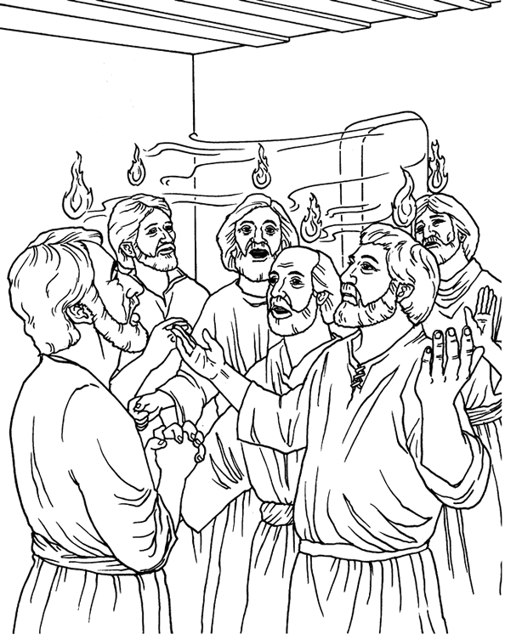

**Exercise**

1. In which form did the Holy Spirit come on the disciples?
2. Name any event that happened on the Pentecost day.
3. Who preached on the Pentecost day?
4. Draw, frame and color the Holy Spirit coming upon the disciples.

**WEEK:3**

**Lesson 1**

**How the holy spirit helped the early Christian**

**Read;**

Acts3:38-47

1. **Ways how the Holy Spirit helped the apostles.**

* To preach the word of God.
* To live and share things together.
* To perform miracles.
* To endure hardships
* To speak to leaders without fear.

1. **How the Holy Spirit helps us today**.

* To know what is right and wrong.
* Gives us hope in times of trouble.
* Protects us from sin and Satan.
* Guides us in prayer and worship.
* To endure hardships.

**Exercise**

1. State two ways how the Holy Spirit helped the first Christians.
2. How does the Holy Spirit help the Christians today?

**Lesson 2**

**Gifts of the Holy Spirit and how to use them**

**Read;**

1corinthans 12:1-11

1. There are nine gifts of the holy spirit namely;

* Wisdom
* Knowledge
* Faith
* Healing
* Working miracles
* Prophesy
* Speaking new tongues
* Interpreting tongues
* Knowing a person with an evil spirit( discernment )

1. **Activities we do together when guided by the holy spirit**:

* Reading the Bible.
* Praying together
* Sharing experiences
* Sharing meals
* Selling possession to help one another.

**Exercise**

1. Identify any four gifts of the Holy Spirit.
2. Which gift would you desire to have?
3. Apart from the above, name any other two gifts that God gave us.

**Lesson 2**

**THE WORSHIPPING COMMUNITY**

1. What is worship?

Worship is a way of praying and showing respect to God.

1. **Ways of worshipping God**

**Read;**

Psalms 150:1-6

* Offering to God.
* Reading the bible.
* Singing hymns /religious songs.
* Dancing
* Waving hands
* Playing musical instruments.
* Clapping
* Jumping

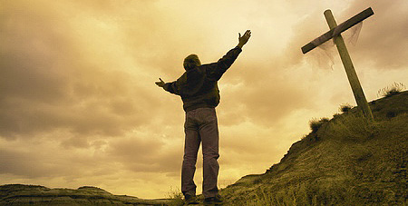

**Exercise**

1. What is worship?
2. Give three ways of worshipping God.
3. Draw people worshipping God.

WEEK:5

**Lesson 1**

**Read;**

Psalms 100: 1-5

1. **Why should Christians worship God?**

Christians worship God because;

* God saved us from sins
* He is our creator
* God is greater than all gods and people
* He is the kings of kings
* He will judge all the people with justice
* He gives us life, food, clothes and other needs
* He rules over all the people of the world

1. **Examples of people who worshiped God are**;

* Jacob
* Isaac
* King David
* King Solomon
* Daniel

**Exercise**

1. Identify any two people in the Bible who worshipped God.
2. Give three reasons why we worship God.

**Lesson 2**

**PRAYING TO GOD**

**Read;**

Matt6;5-8

1. What is prayer?

Prayer is a way of talking to God

1. What should a Christian do before praying?

* Repenting(ask God for forgiveness)
* Forgive those who anger him /her.
* Humble himself/her self.
* Turn his /her mind towards God.
* Kneel down when praying

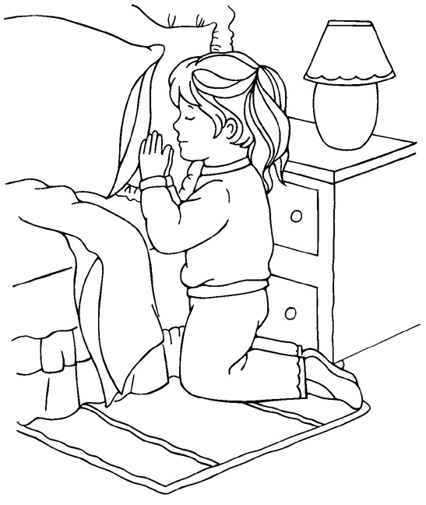

1. **Reasons why people pray to God**

* To ask for forgiveness.
* People ask for protection.
* People pray to get blessings.
* To thank God for what he has done for them.
* People pray to get daily needs ;like food, clothes, shelter etc

1. **When do we pray?**

* Before a meal
* Before sleeping.
* After bed
* When in troubles
* When going for a journey etc.

**Exercise**

1. What is prayer?
2. Write two things a Christian should do before praying.
3. Give two reasons why people pray**.**
4. Draw yourself praying.

**WEEK:6**

**Lesson 1**

**Personal prayers**

**Read;**

Matt7;7 -11

1. What is a personal prayer?

A personal prayer is a prayer said alone / individually.

**2. Types of personal prayers**

1. **Personal thanks-giving prayer**

Is p**ra**yer said to thank God for something he has done e.g. healing.

1. **Confession prayer**

Is a prayer said to ask God to forgiveness.

1. **Petition prayer**

Is prayer said to ask for daily needs e.g. healing, food, shelter etc.

1. **Intercession prayer;**

Is a prayer where one prayers for others.

**Exercise**

1. Define a personal prayer.
2. Name two types of personal prayers.
3. Which type of prayer is said to ask for forgiveness?

**Lesson 2**

1. **People who need to be prayed for;**

* children
* teachers
* the sick
* the prisoners
* the mad
* the leaders
* the war victims
* parents
* the dumb and deaf

1. **Places where we can pray from:**

-You can pray from anywhere in case you feel to pray.

-You can pray from these places:

* Form the church
* Classroom
* Bed room
* In a vehicle
* On the mountain or hill

1. **Examples of people who prayed God and were answered**:

* Abraham
* Jacob
* Jesus
* King David
* Daniel
* Samson
* Ruth
* Simon Peter
* Jeremiah etc

**Exercise**

1. Name three groups of people who should be prayed for.
2. Apart from a church, where else can a Christian pray from?
3. What do you know about these people in the Bible?
4. Samson
5. Daniel

WEEK:7

**Lesson 1**

**THE LORD’S PRAYER**

**Read;**

Matthew 6:9-14

1. What is the Lord’s Prayer?

This is the prayer Jesus taught his apostles.

NB. Recite the Lord’s Prayer.

1. **Requests are made in the Lord’s Prayer**

* God’s kingdom to come.
* God’s will to be done.
* To give us our daily food. (bread)
* To forgive our trespasses.
* Not to lead us into temptations.
* To deliver us from evil.

1. What lessons do you learn from the Lord’s Prayer?

* To glorify/ praise God.
* To ask for God’s kingdom to come.
* To ask God for deliverance in case of trouble.

**Exercise**

1. Which prayer did Jesus teach his apostles?
2. Identify any two requests made in the Lord’s Prayer.
3. Why do you think Jesus taught his disciples this prayer?

**Lesson 2**

**THE TEACHINGS OF JESUS**

**Read;**

Matt 5:43-48

1. Jesus teaches us Christian values.
2. What are values?

Values are beliefs about what is right and wrong.

1. **Example of Christian values.**

* Being honest/ faithful.
* Being responsible.
* Helping others.
* Respecting elders.
* Loving one another.
* Forgiving one another.

1. **How Jesus helped others.**

* He healed the sick.
* Jesus fed the hungry.
* He raised the dead.
* He healed the deaf and the dumb.
* He healed the blind. etc

**Exercise**

1. Name any two Christian values.
2. Mention any two needy groups of people.
3. Identify four ways you can help the needy.

WEEK:8

**Lesson 1**

**Parables taught by Jesus**

1. What is a parable?

A parable is a short story with hidden spiritual meaning.

1. **Examples of parables used by Jesus.**

* The parable of the sower (Mark 4:1-9)
* Parable of the lost son prodigal son (Luke15:11-31)
* Parable of the Good Samaritan (Luke 10:25-37)
* Parable of the ten virgins(Matt25:1-13)
* Parable of the lost coin(Luke15:8-10)
* Parable of the lost sheep(Luke15:1-7)
* Parable of the talents (Matt25:1-13)
* Parable of the tenants(Luke20:9-16) etc

1. **Jesus used parables because**;

* He didn’t want others to know what he was saying.
* For the disciples to understand well.
* To fulfill what was said about him.

**Exercise**

1. Define a parable.
2. Name any two parables in the Bible.
3. Why did Jesus use parables in his teachings?

**Lesson 2**

**God given abilities (talents)**

**Read;**

Matt25:1-13

1. What is a talent?

A talent is a gift from God.

-Talents are not learnt but natural.

1. Examples of talents:

* singing
* dancing
* drama
* painting
* drawing
* Playing games and sports.
* Good public speaking.

1. How to use your talent(s) well:

* Never be proud.
* Use it to help others.
* Use it to glorify God.
* Do not hide your talent.
* Use your talent to make it perfect.
* Use it to earn a living.

**Exercise**

1. What is a talent?
2. Name any two talents God gave us?
3. What is your talent?
4. How can one misuse his/her talent?

WEEK: 9

**Lesson 1**

**Read;**

John3 :16

**Characteristics of God found in Jesus**

1. Children adopt some characteristics from their parents.
2. Jesus also had characteristics from God, his father.
3. These were;

* Love
* Kindness
* Holiness [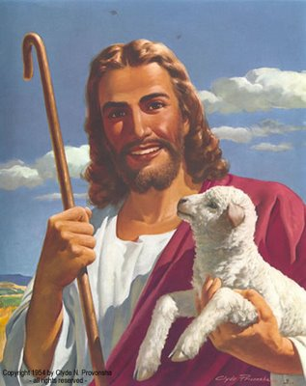](http://2.bp.blogspot.com/_mSxLFTmqqRs/SaIPNglbDSI/AAAAAAAAAHM/VDhHoCk09uI/s1600-h/jesus+smiling.jpg)
* Devine power
* Being eternal
* Knowing people’s thoughts.
* Knowing the past, the present and the future.

**Exercise**

1. Identify any two things which showed that Jesus was a son of God.
2. Name the three persons in the Trinity.
3. Why did God send his son on earth?

THE END

**TERM ThrEE**

**WEEK 2**: Lesson 1

**spellings**

1. Nazareth
2. Jordan
3. Ararat
4. Red sea
5. Canaan

**FORGIVENESS AND ACCEPTANCE**

1. What is forgiveness?

Forgiveness means to stop being angry with some body for something he/she has done wrong.

2. If you want somebody to stop being angry with you, say, “please forgive me” or “please, am sorry.”

3. We should forgive one another and also ask God to forgive us.

**4. Traditional ways of encouraging forgiveness**

* Paying a fine i.e. a cock, goat etc.
* Sharing a meal.
* Saying sorry to a person wronged.
* Using a middleman (mediator) to reconcile the two people.
* Re-accepting the offender into the family.

**Activity**

1. Explain the meaning of the word forgiveness.
2. Emma poured Suzan’s juice accidentally. What should these two do to become friends again?
3. Emma_____________________________
4. Suzan______________________________
5. Draw, name and colour any one way traditional way of forgivenss.

**WEEK 2**: Lesson 2

**spellings**

1. forgiveness
2. traditional
3. sorry
4. reconcile
5. angry

**1. Reasons why we need to forgive**

We need to forgive others because:

* God also forgives us.
* Everybody makes mistakes.
* Forgiveness helps us to live and work together happily.
* Forgiveness prevents bad out comes like hatred, fighting etc.
* It serves as a lesson to the person forgiven to also forgive others who wrong him/her.

2. Jesus showed us an example when he forgave those who hated him.

**2. Examples of people who forgave one another in the Bible**

* Jacob and Esau(Genesis33:1-11)
* Joseph and his brothers(Genesis45:1-5)
* King Darius and Daniel(Daniel 6:13-23)
* The prodigal son and his father(Luke 15:11-31)

**Activity**

1. Give two reasons why we should forgive one another.
2. What is sin?
3. Name any two examples of sin.
4. What should we do when we sin?
5. Which parable teaches us to forgive one another?

**WEEK 3**: Lesson 1

**spellings**

1. forgive
2. repent
3. mistake
4. hate
5. hatred

**Resolving misunderstanding without violence**

1. To resolve means to find a solution or an answer to a problem.

2. Violence means an act of using physical force e.g. fighting.

3. **How Jesus teaches about resolving misunderstandings without violence.**

**Matthew** 18:15-16

**Steps**:

* Solve it in private with a person who has wronged you.
* If the person does not listen, take/call other two people.
* If he/she does not listen to the two, take it to the church (group).
* If he/she does not listen to the church (group), take the case to LC or court.

**Activity**

1. Define the term violence.
2. What should you do after annoying a friend?
3. What should you do if somebody does wrong to you but doesn’t apologize?

**WEEK 3**: Lesson 2

**spellings**

1. violence
2. misunderstanding
3. resolve
4. annoy
5. friend

**Causes of misunderstandings/violence**

* Physical differences e.g. height, colour and body shape.
* Religious differences e.g. some are Catholics, Protestants, Pentecostals etc.
* Cultural differences e.g. Buganda, Acholi, Karamajong.
* Racial differences e.g. the black and white.
* Home differences e.g. the rich and the poor.
* Differences in education.

2. We are all God’s children regardless of our differences.

3. We should accept our differences to live peacefully.

**4. Ways of accepting and tolerating our differences**

* Loving and caring for one another.
* Over looking our differences.
* Praying together.
* Sharing times of sorrow and joy.
* Knowing that we are all God’s children.

**Activity**

1. Mention any two differences that exist among people.
2. Identify two ways we can live peacefully even though we are different.

**WEEK 4**: Lesson 1

**spellings**

1. difference
2. physical
3. religious
4. cultural
5. racial

**TREATING OTHERS FAIRLY**

1. Being fair means treating each person equally.

2. Unfairness is the opposite of fairness.

1. **Common examples of fair behaviour** 
   * Marking all pupils’ books and awarding right marks.
   * Allowing all family members to have meals.
   * Buying needs to all children in a family.
   * Punishing all late comers at school.

4. **Common examples of unfairness**

* Marking some pupil’s books and leaving others unmarked.
* Punishing some late comers and leaving others unpunished.
* Forcing an adult to follow a certain religion.
* Buying needs for some children and leaving others.
* Giving food to some children and starving others.

**Activity**

1. What is fairness?
2. Identify any two unfair behaviour.
3. How can we treat all people at home fairly?

**WEEK 4**: Lesson 2

**spellings**

1. fair
2. unfair
3. behavior
4. treat
5. punishment
6. **Results of fair behaviour.**
   * Bring happiness to people.
   * It pleases God.
   * It solves mis-understandings.
   * It brings God’s blessing.
   * It brings unity among people in the family.

2. **Results of unfair behavior**

* Fighting
* Hatred
* Unhappiness
* Quarreling
* Revenge
* Annoying God
* Curses
* Spread of diseases among the people

**Activity**

1. Ssempa went to a hotel with his step-mother. She bought chips and chicken for her two children and bought posho and beans for Ssempa.

1. Was this a fair act?
2. State any two results of this act
3. Identify two effects of treating everybody fairly?

**WEEK5**: Lesson 1

**spellings**

1. annoying
2. blessing
3. quarreling
4. cursing
5. unity

**Reasons why some people behave unfairly**

* Too much love for money.
* Failure to obey God’s commandments.
* Need to please one person/group of people.
* Failure to know the right way of doing things.
* Too much love for success.
* Failure to listen to advice.
* Need to revenge.
* Failure to follow the rules and laws.

**Activity**

1. State any three reasons why some people behave unfairly.
2. Why do you think Judas Iscariot betrayed Jesus?

**WEEK 5**: Lesson 2

**spellings**

1. revenge
2. laws
3. rules
4. commandments
5. failure

**How John the Baptist teaches us to be fair**

Luke 3:10-13

John the Baptist teaches us the following:

* To share with others.
* Not to collect money (tax) more than what the law requires.
* Not to take away ones money by force.
* To be contented /satisfied with our pay.

NB: John the Baptist teaches us not to be corrupt people.

**Activity**

1. What does John the Baptist teach about corruption?
2. Where was John the Baptist baptizing from?
3. How did he meet his death?

**WEEK 6**: Lesson 1

**spellings**

1. baptize
2. baptist
3. tax
4. corruption
5. contented

**Cheating**

1. What is cheating?

It means taking something from somebody in a dishonest or unfair way.

**2. Forms of cheating**

* Not giving back balance/change to your parents after buying something.
* Getting answers from a book, paper or friend in exams.
* Exchanging a bad pencil or pen with another person without his/ her knowledge.
* Exchanging cards in a play.
* Embezzling company/church funds.
* Diverting school fees to buying personal needs.

**Activity**

1. Explain the term cheating.
2. Identify any two forms of cheating common in schools.
3. What can you do to a person who cheats an examination?

**WEEK 6**: Lesson 2

**spellings**

1. cheating
2. honest
3. dishonest
4. embezzle
5. exchanging

**Examples of people who cheated in the Bible**

**a)Jacob** ;

* Cheated his brother, Esau’s blessing .(Genesis27:1-33)
* He also cheated his uncle, Laban’s flock.(Genesis3:31-43)

**b)Judas Iscariot**;

* He used to cheat church funds (John12:1-6)
* He was bribed for 30 silver pieces to betray Jesus.(Matthew26:14-16)

**c) The sons of priest Eli**:

* Used to cheat God’s offerings.(1Samuel2:12-17}

**Activity**

1. Who cheated his brother’s blessing in the book of Genesis?
2. Why Judas Iscariot was called a cheat?
3. Who was the father of Esau and Jacob?

**WEEK 7**: Lesson 1

**spellings**

1. bribe
2. cheated
3. betray
4. sacrifice
5. offering

1. **Reasons why cheating is bad**

* It is against God’s commandments.
* It stops some people from being successful.
* People do not trust a cheat.
* Cheating is punishable
* It leads to curses
* It stops God’s blessing i.e. God does not bless a cheat
* Cheats will not go to heaven

**2. Ways how you can avoid cheating**

* Following God’s commandments.
* Avoid being money greedy.
* Respect rules and laws of an area or place.
* Report cheats to police, teachers or parents.
* Work hard for success.

**Activity**

1. State any two reasons why cheating is a bad act.
2. How can cheating be controlled?

**WEEK 7**: Lesson 2

**spellings**

1. heaven
2. curses
3. success
4. respect
5. greegy

**JESUS BRINGS JOY**

**Old prophesies about Jesus**

The following were fore told about Jesus’ birth and were true:

* That Jesus was to be born by a virgin woman.( Isaiah7:14)
* That Jesus would be born in a small town called Bethlehem.(Micah5:2)
* That he would be born in the lineage of King David.(Luke2:4)
* That Jesus would be a saviour for all people.

**Activity**

1. Who were the parents of Jesus?

1. The mother_____________________________
2. The earthly father________________________
3. The heavenly father_______________________
4. Whose descendant was Jesus?
5. Name the prophet who said that Jesus will be born in Bethlehem.

**WEEK 8**: Lesson 1

**spellings**

1. prophet
2. prophecy
3. descendant
4. born
5. birth

**Jesus’ birth**

1. Jesus was born on the first **Christmas.**
2. Christians celebrate the birth of Jesus Christ on **25th December** every year.
3. Jesus was born in the town of **Bethlehem** but grew up from **Nazareth**.
4. The shepherds were the first people to know about Jesus’ birth?

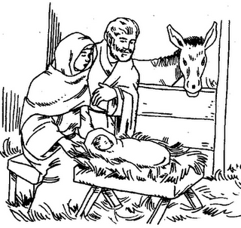

1. The wise men (Magi) came from the Far East following the bright star.
2. The Magi gave baby Jesus these gifts;
3. gold
4. myrrh
5. frankincense
6. Baby Jesus was taken to Egypt because **King Herod** wanted to kill him.
7. **Meaning of these names**
8. Immanuel; God is with us
9. Jesus; The saviour

**Activity**

1. On which day do Christians celebrate Jesus’ birth?
2. Which African country was visited by baby Jesus?
3. Name any two gifts given to Jesus by the Magis.
4. What do these names mean?
5. Jesus
6. Immanuel

**WEEK 8**: Lesson 2

**spellings**

1. Christmas
2. myrrh
3. Nazareth
4. Shepherd
5. frankincense

**Preparation for Christmas**

1. How do Christians prepare for Christmas celebrations?

* Repenting their sins.
* Buying new clothes and shoes.
* Cleaning their compounds.
* Sending Christmas cards to friends and relatives.
* Praying together in churches.
* Singing Christmas carols.
* Decorating their houses.

2. **How we can share Christmas joy with others**

* By reading the bible together.
* Praying together.
* Singing Christmas songs / carols.
* Listening to Christmas carols.
* Exchanging gifts.
* Eating and drinking together.

**Activity**

State any three ways we can prepare for Christian.

2. Draw and colour yourself and your family celebrating a Christmas day.

**THE END**